**Assignment 6**

**Description:**

1. Assume that you have the following JavaScript code:

Code – 1

Class Animal {

constructor(legs) {

this.legs = legs;

}

walk() {

console.log('walking on ' + this.legs + ' legs');

}

static helloWorld() {

console.log('Hello World');

}

}

class Bird extends Animal {

fly() {

console.log('flying');

}

}

Bird.helloWorld();

myanimal = Animal("Four");

myanimal.walk();

myfly = new Bird("Parrot");

myfly.fly

**Show the output.**

1. **Get the console log output for all called function.**
2. **If expected output is not getting find out the correct code and fixed it.**

**Output:**

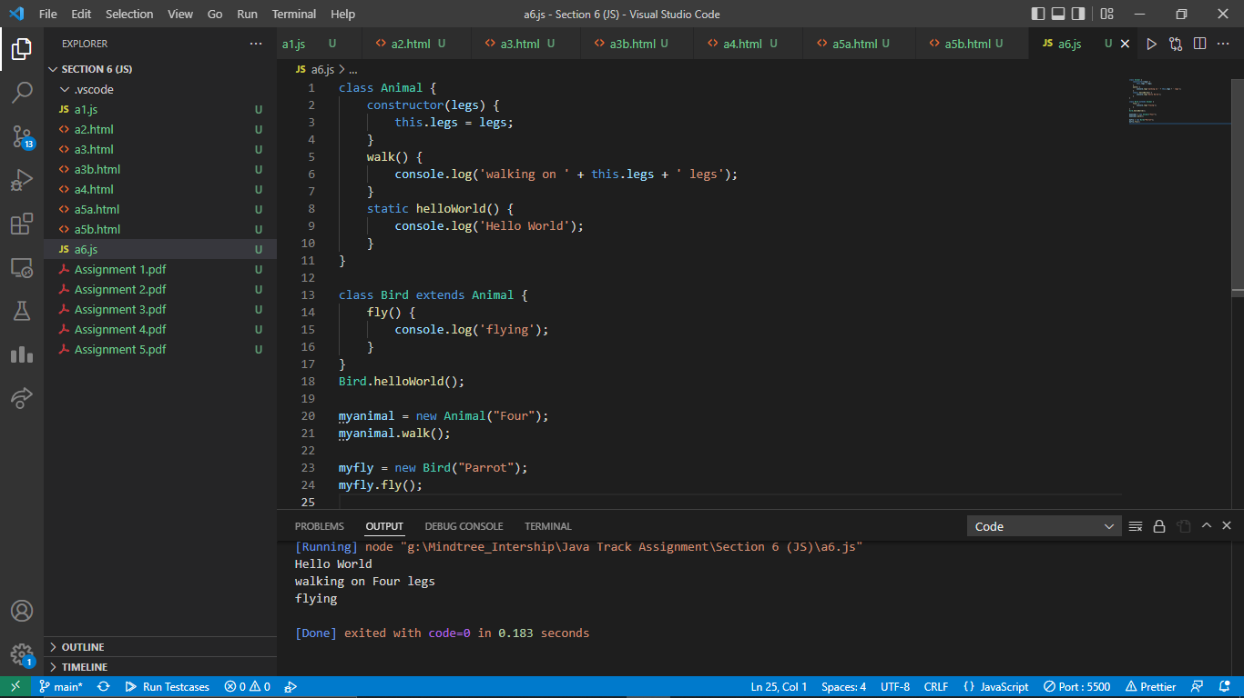

**Performance Outcomes:**

Upon successful completion of the assignment, the participant is well versed in

1. User are able to create class and used them as per required.
2. Knowledge to use this and constructor creation and object creation using javascript for OOP mechanism.
3. Able to know how can assign and get variable value using calling class method and function.